Part 1 -- AWS Architecture Design for Real- Time Fraud Detection
1.AWS Services Tables
AWS Services | How it works in this application | High -performance | Security | Cost-efficiency
AWS IAM | Manages admin access and defines least-privilege roles for EC2, S3, DynamoDB, SQS and SNS, ensuring secure service operation. | Centralised identity management avoids misconfigurations that could disrupt system availability. | Enforces strong authentication and least-privilege authorisation; integrates with CloudTrail for full auditability. | Free service; reduces operational overhead and prevents costly security failures.
Amazon EC2 + Auto Scaling Group | Runs the fraud detection workers that dequeue messages from SQS, load models from S3, execute inference and publish alerts. | ASG provides horizontal scaling and multi-AZ availability, maintaining low latency under variable load. | Instances run in private subnets, use IAM roles for controlled service access, and are protected by Security Groups. | Auto scaling avoids paying for idle capacity and dynamically adjusts compute based on demand.
Amazon SQS | Acts as a durable queue between ingestion and processing, buffering all transaction tasks. | Prevents worker overload, supports retries and smooths traffic spikes to ensure stable throughput. | Strict IAM policies and VPC Endpoints secure queue access; messages use KMS encryption. | Serverless and pay-per-request with no infrastructure provisioning.
Amazon ALB | Receives HTTPS requests from the bank and routes them to healthy EC2 workers across multiple AZs. | Performs health checks, balances traffic and provides low-latency ingress. | Manages TLS termination and serves as the first security boundary before private workloads. | Usage-based pricing with no maintenance; scales automatically with traffic.
Amazon DynamoDB | Stores fraud-detection results (score, decision and timestamp) for analytics and audit retrieval. | Delivers single-digit millisecond reads/writes and automatically scales with workload. | KMS encryption and fine-grained IAM policies restrict access to authorised users only. | On-demand capacity removes provisioning needs and charges only for consumed R/W units.
Amazon S3 | Hosts versioned ML models and stores long-term audit logs  produced by the fraud detection workers. | Provides eleven-nines durability and high availability for model artefacts. | Encrypted by default; bucket policies and VPC Endpoints prevent unauthorised access. | Low-cost storage with lifecycle policies for archival tiers (e.g., Glacier).
Amazon CloudWatch | Collects metrics and logs from ALB, EC2 and SQS; triggers alarms for failures and scaling policies. | Enables proactive recovery and supports auto scaling based on real-time metrics. | IAM governs log and dashboard access; logs support auditing and operational traceability. | Pay-as-you-go for metrics and logs; avoids running custom monitoring infrastructure.
Amazon SNS | Publishes fraud alerts from EC2 and system alarms from CloudWatch to the analytics team. | Highly available, low-latency delivery enables rapid escalation of high-risk events. | IAM controls publisher and subscriber permissions; topics can be encrypted. | Pay only per message; no servers to manage, ideal for event-driven notifications.
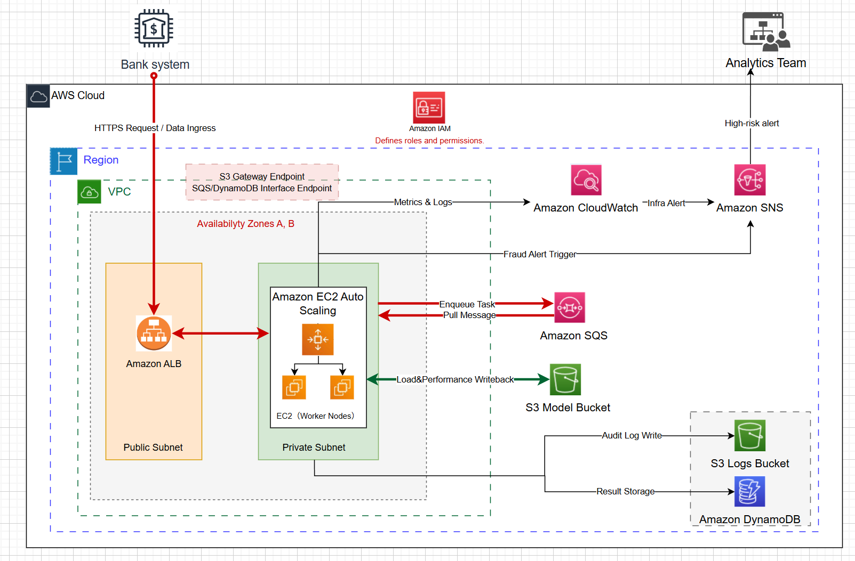This architecture implements a hybrid asynchronous workflow to provide secure, low-latency ingestion and resilient fraud-detection processing. The Bank System sends real-time transactions via HTTPS through a secure connection to the Application Load Balancer (ALB). The ALB forwards each request to an EC2 instance in the Auto Scaling Group (ASG). The instance immediately writes the transaction to Amazon SQS and returns a synchronous acknowledgement to the bank, ensuring low perceived latency while shifting computation to the asynchronous backend. SQS then acts as a durable buffer that decouples ingestion from processing.
EC2 workers continuously pull messages from SQS, load model artefacts from the S3 Model Bucket and perform inference. S3 Gateway Endpoints and SQS/DynamoDB Interface Endpoints provide private-network access, ensuring all data remains inside the VPC without traversing the public internet. Each processed task generates three outputs: a fraud-detection result written to DynamoDB, an audit log stored in the S3 Logs Bucket and a fraud alert published to SNS. The worker then deletes the corresponding SQS message.
Service continuity is supported through multiple resilience mechanisms. SQS provides durability and retry-based recovery during worker failures. The ALB and ASG span multiple Availability Zones, offering high availability and routing traffic only to healthy instances. Auto Scaling—driven by CloudWatch metrics such as queue depth and CPU utilisation—adds or removes EC2 workers to prevent overload. Multi-AZ deployment isolates failures, and rolling ASG updates enable non-disruptive model version upgrades. CloudWatch-to-SNS alerts notify the team of operational issues, ensuring timely intervention before service degradation occurs.

